**INTRODUCTION**

* 1. **Overview**

**Navigate to your zoom preferences and select “Virtual Background” from the menu on the left. Click on the small grey”+” button right across from “choose virtual background”.**

* 1. **Purpose**

**The purpose of Virtual Background feature allows you to display a Viedo as your background during a Zoom meeting which can provide you with more privacy or a consistent and professional look for a presentation**

**2. problem definition& design thinking**

**2.1 Empathy Map**

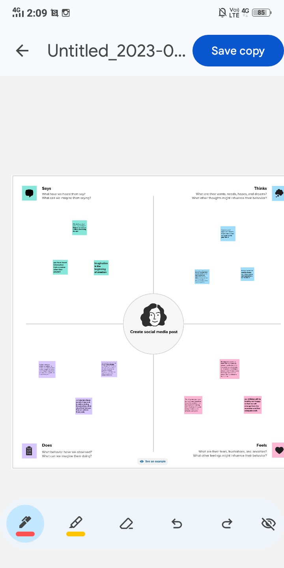

**2.2 Ideation & Brainstorming Map**

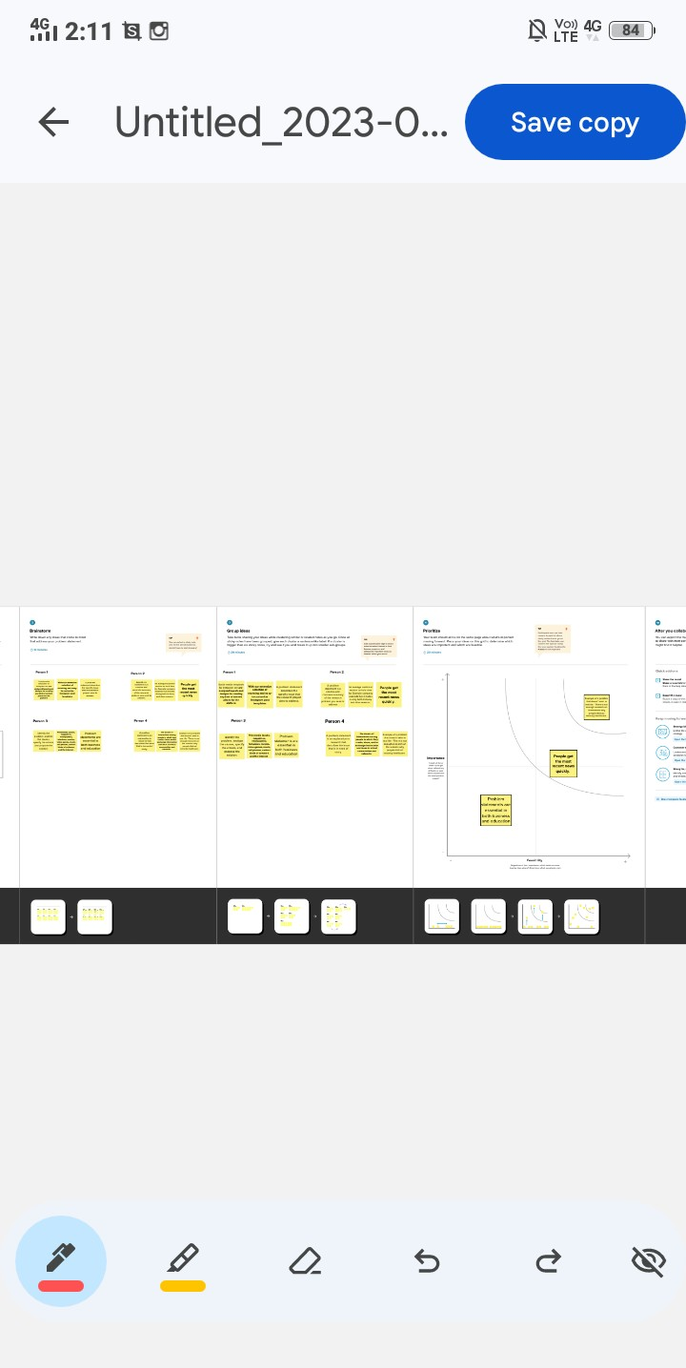

1. **RESULT**

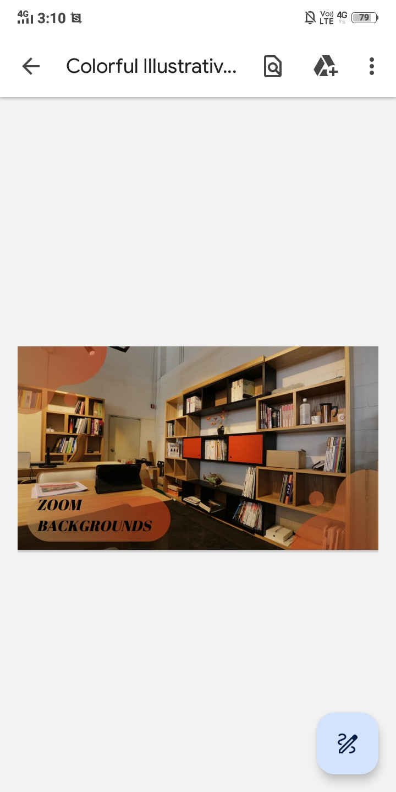

1. **ADVANTAGES & DISADVANTAGES**

**ADVANTAGE:**

1. conceal your personal/office space
2. Build Brand Recognition and trust.
3. Best practices when using a virtual background in Zoom

**DISADVANTAGE**:

1. Bandwidth requirements: Zoom has faces several privacy and security concerns in the past, which can be a challenge for students who have limited access to high- speed internet.
2. Zoom fatigue: Student and instructors can experience Fatigue from participating in multiple online classes on Zoom, which can affect their engagement and learning outcomes.
3. Limited personal interaction: Online classes on Zoom lack the personal interaction that traditional face-to-face Classes offer, which can make it difficult for students to from connections with their classmates and instructors.

**5 APPLICATIONS**

I have used Mural application and canva application

1. **CONCLUTION**

We have created zoom backgrounds cover with the help of canva

1. **FUTURE SCOPE**

We were planning to join the Grapic designing course